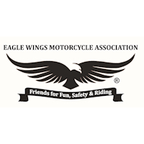
Confidentiality Agreement of Member Information of

Eagle Wings Motorcycle Association

It is understood and agreed that all membership information is private and should be treated in the same way we would protect our own personal information from those without the need to know or possess. Accordingly, all membership information is only to be used for official business and as it relates to the operations of EWMA. It is further agreed that no information from the membership listing or any other Member information can be transferred or distributed, in any format, to persons, organizations, or business interests, without the express written consent of the Home Office.

It is further understood that all membership information and media is the property of the Eagle Wings Motorcycle Association and is to be transferred in its entirety, along with all other EWMA property, to succeeding Officers, or at the direction of the appointing Officer.

It is also understood that as a participant of any focus group with regards to Eagle Wings Motorcycle Association, I agree to not disclose, share, or discuss the information that I/we am privy to with anyone not involved in the group I’m/we’re participating in.

I/We, , and ,
agree to this Confidentiality Agreement and agree to adhere to the fullest extent in safekeeping and protecting the private information of the membership and Eagle Wings Motorcycle Association as set forth above.

Signature: Date:

Print
Name:

Signature: Date:

Print
Name:

